ព្រះរាជាណាចក្រកម្ពុជា

ជាតិ​ សាសនា ព្រះមហាក្សត្រ

Institute of technology of Cambodia

Department of Information and communication Engineering



The lesson taking about function and structure.

TP9-Function and Structure

TP: Algorithm and Programming

Lecturer: BOU CHANNA

Student: VEN THON

ID: e20191250

Group: I3-GIC-C

Year: 2021-2022

Contents

Problem1: 3

Problem2: 4

Problem3: 5

Problem4: 6

Problem5: 8

# 

# Problem1:

Write a function to check whether a number given as a parameter is an even or odd number. This function return a boolean values. Create your program to get n from user then call this created function in main to test.

bool checkEvenOdd(int n);

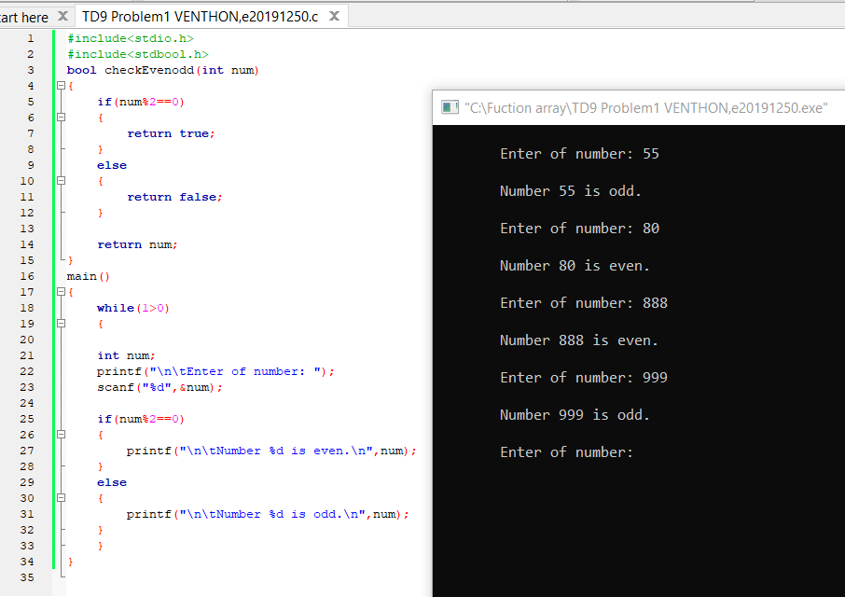a

# Problem2:

Write a function that computes a sum of numbers in an array, where the array is passed to function as parameter. Initialize an array with your preferred size being greater than 10 and data to fill in array. Next call your function to compute sum and display the result.

int sumDataInArray(int a[]);

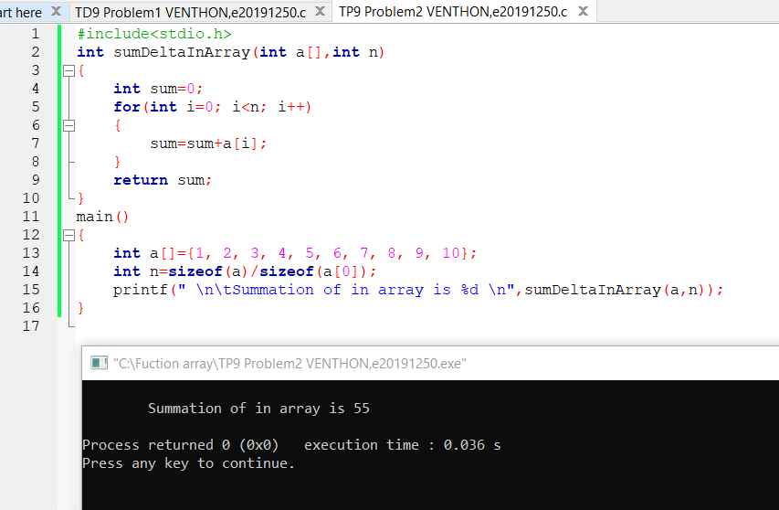

# Problem3:

 Write a function to compute

(1! + 2! + 3! + ... + n!)/(1+2+3+...+n). Create your program to get n from user then call this created function in main.

int computeSeries(int n);

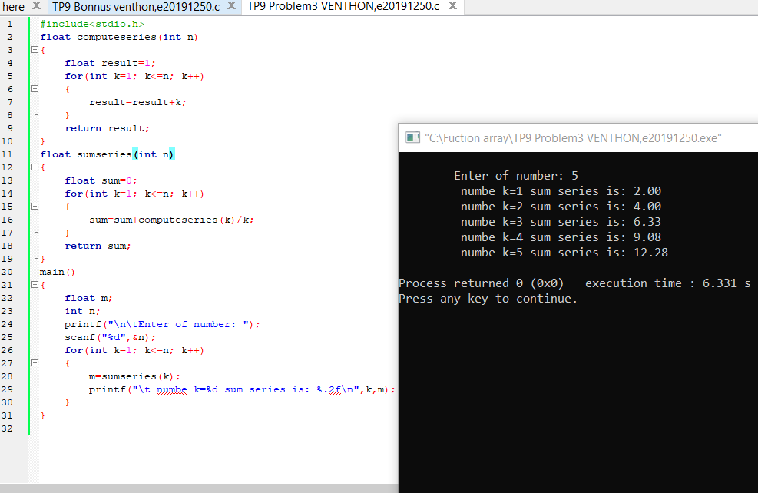

# 

# Problem4:

Define new data structures below

Date : consists of day, month and year.

Employee : consists of employee name, phone contact, Date of birth, salary, start working date and gender.

Create an array to store 7 employee information. Then create:

a) A function to ask a user to enter info and store in array

void enterData(Employee emp[]);

b) A function to display data in array

void displayData(Employee emp[]);

c) A function to display employee info that have highest salary

void displayEmployeeHighestSalary(Employee emp[]);

d) A function to return the lowest salary among all employees.

float findLowestSalary(Employee emp[];

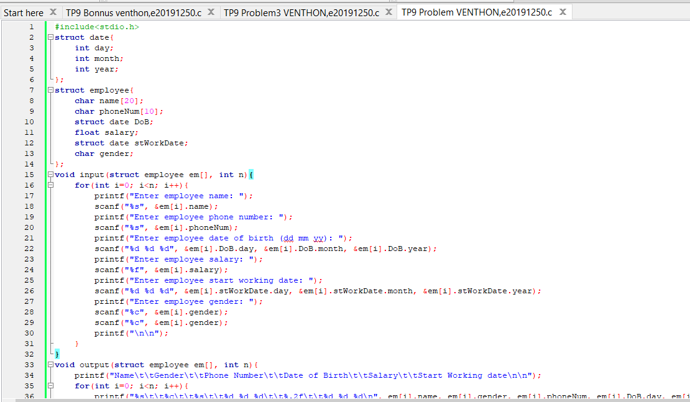

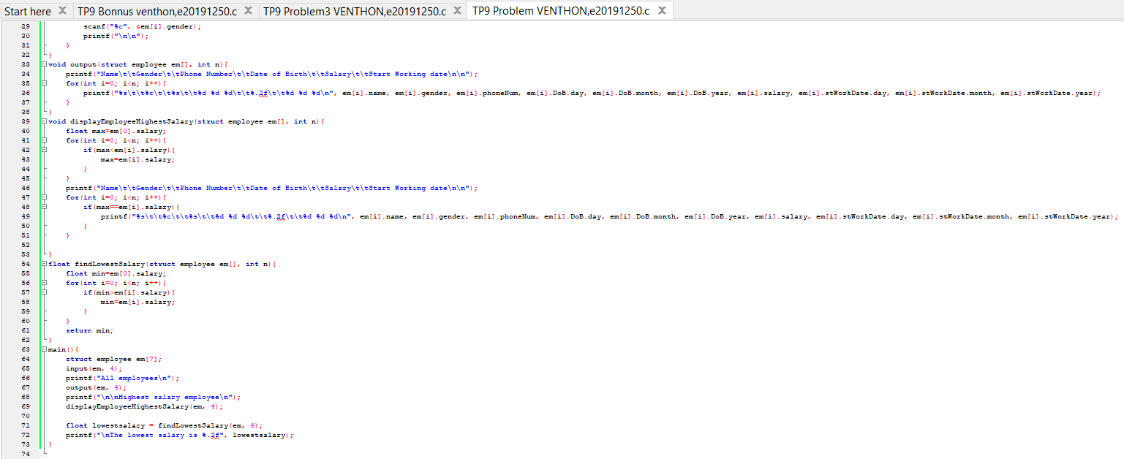

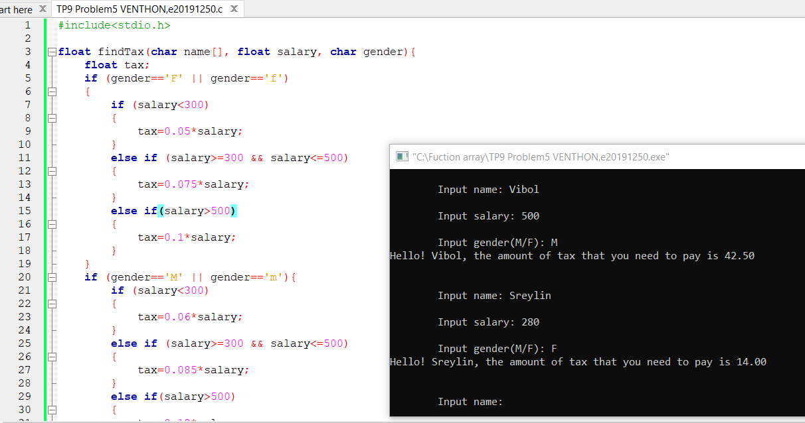

# Problem5:

Write a function to compute how much tax a person should pay. This function takes user name, salary, and gender as parameters. Following rules are used to find tax:

-Female person with salary less than 300$, pay tax 5%.

-Female person with salary between 300 and 500, pay tax 7.5%.

-Female person with salary more than 500$, pay tax 10%.

-Male person with salary less than 300$, pay tax 6%.

-Male person with salary between 300 and 500, pay tax 8.5%.

-Male person with salary more than 500$, pay tax 12%.

This function compute tax and return values.

float findTax(char name[], float salary, char sex);

